1. Create a database called “sample”.

2. Create a collection called “test_data” and load the following data into the collection.

db.test_data.insertMany([
{
class: "NO",
age: 35,
menopause: "premeno",
deg_malig: 3,
breast:"left",
breast_quad: "left_low",
irrediat: "no"},
{
class: "NO",
age: 42,
menopause: "premeno",
deg_malig: 2,
breast:"right",
breast_quad: "right_up",
irrediat: "no"},
{
class: "NO",
age: 30,
menopause: "premeno",
deg_malig: 2,
breast:"left",
breast_quad: "left_low",
irrediat: "no"},
{
class: "NO",
age: 61,
menopause: "ge40",
deg_malig: 2,
breast:"right",
breast_quad: "left_up",
irrediat: "no"},
{
class: "NO",
age: 45,
menopause: "premeno",
deg_malig: 2,
breast:"right",
breast_quad: "right_low",
irrediat: "no"},
{
class: "NO",
age: 64,
menopause: "ge40",
deg_malig: 2,
breast:"left",
breast_quad: "left_low",
irrediat: "no"},
{
class: "NO",
age: 52,
menopause: "premeno",
deg_malig: 2,
breast:"left",
breast_quad: "left_low",
irrediat: "no"},
{
class: "NO",
age: 67,
menopause: "ge40",
deg_malig: 1,
breast:"left",
breast_quad: "left_low",
irrediat: "no"},
{
class: "YES",
age: 41,
menopause: "premeno",
deg_malig: 2,
breast:"left",
breast_quad: "left_low",
irrediat: "no"},
{
class: "YES",
age: 43,
menopause: "premeno",
deg_malig: 2,
breast:"right",
breast_quad: "left_up",
irrediat: "no"},
{
class: "YES",
age: 41,
menopause: "premeno",
deg_malig: 3,
breast:"left",
breast_quad: "central",
irrediat: "no"},
{
class: "YES",
age: 44,
menopause: "ge40",
deg_malig: 2,
breast:"left",
breast_quad: "left_low",
irrediat: "no"},
{
class: "YES",
age: 61,
menopause: "lt40",
deg_malig: 1,
breast:"left",
breast_quad: "right_up",
irrediat: "no"},
{
class: "YES",
age: 55,
menopause: "ge40",
deg_malig: 3,
breast:"left",
breast_quad: "right_up",
irrediat: "no"},
{
class: "YES",
age: 44,
menopause: "premeno",
deg_malig: 3,
breast:"left",
breast_quad: "left_up",
irrediat: "no"}
]);

db.test_data.find();
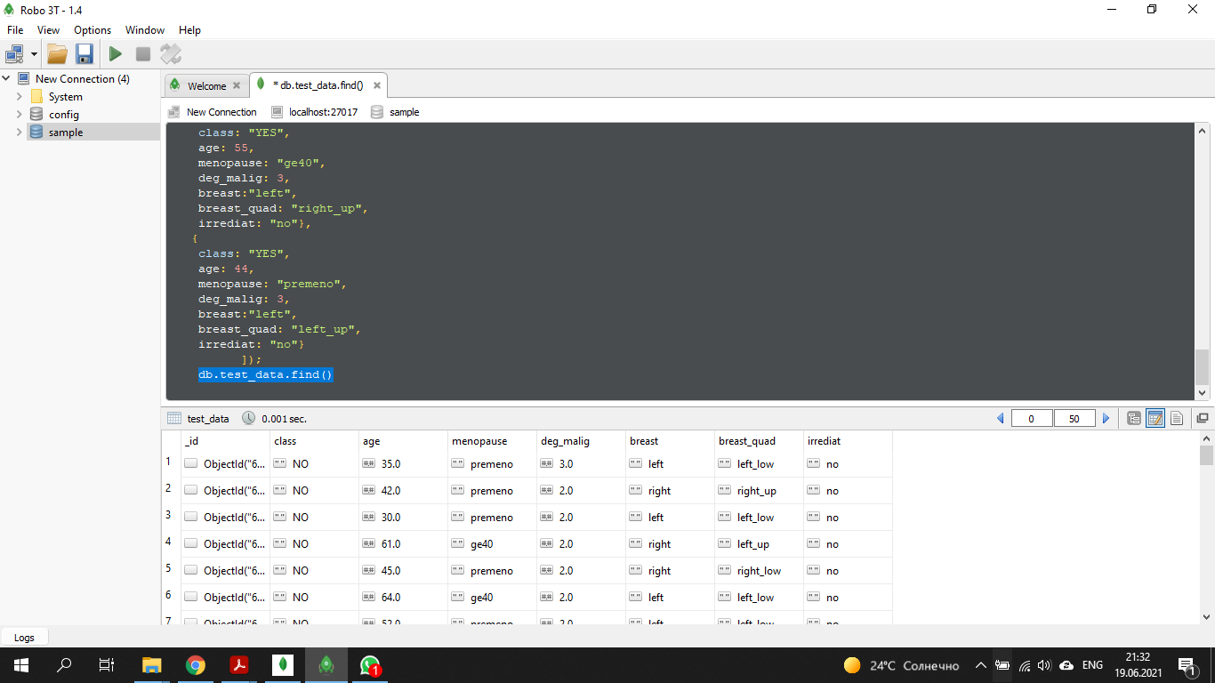

3a. Select all rows where the menopause column has the value “ge40”.
db.test_data.find({menopause:"ge40"});
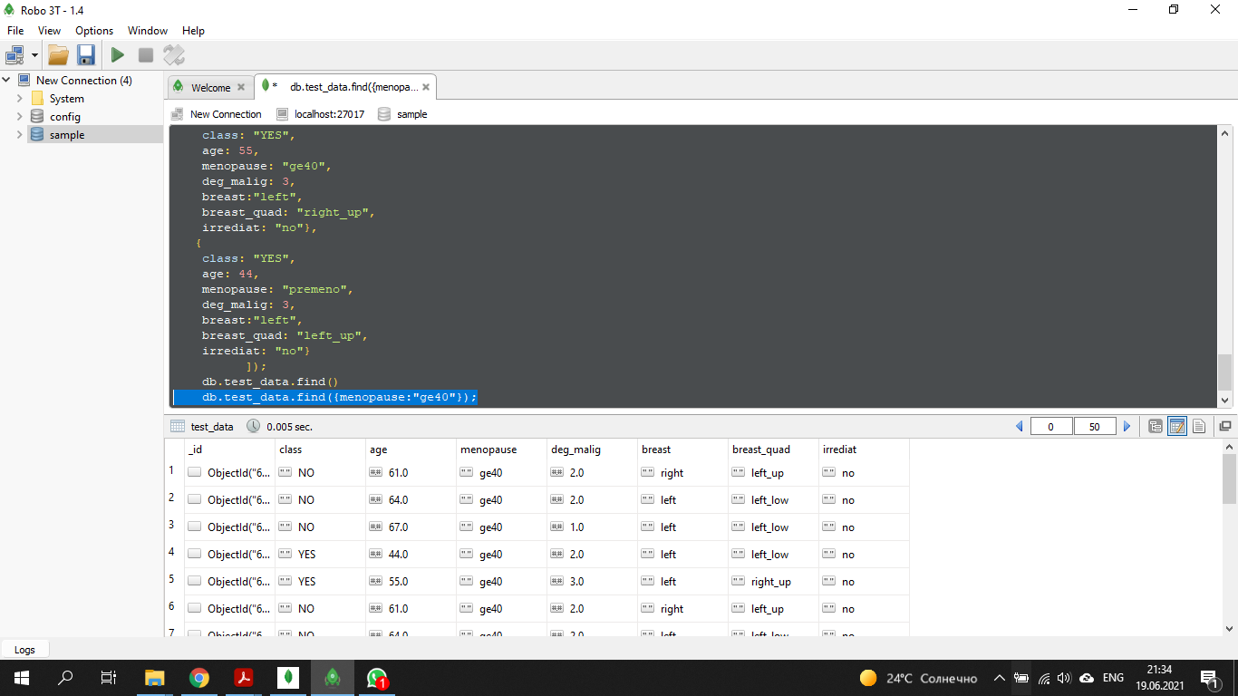
3b. Select all rows where age is less than 41.
db.test_data.find({age: {$lt : 41}});
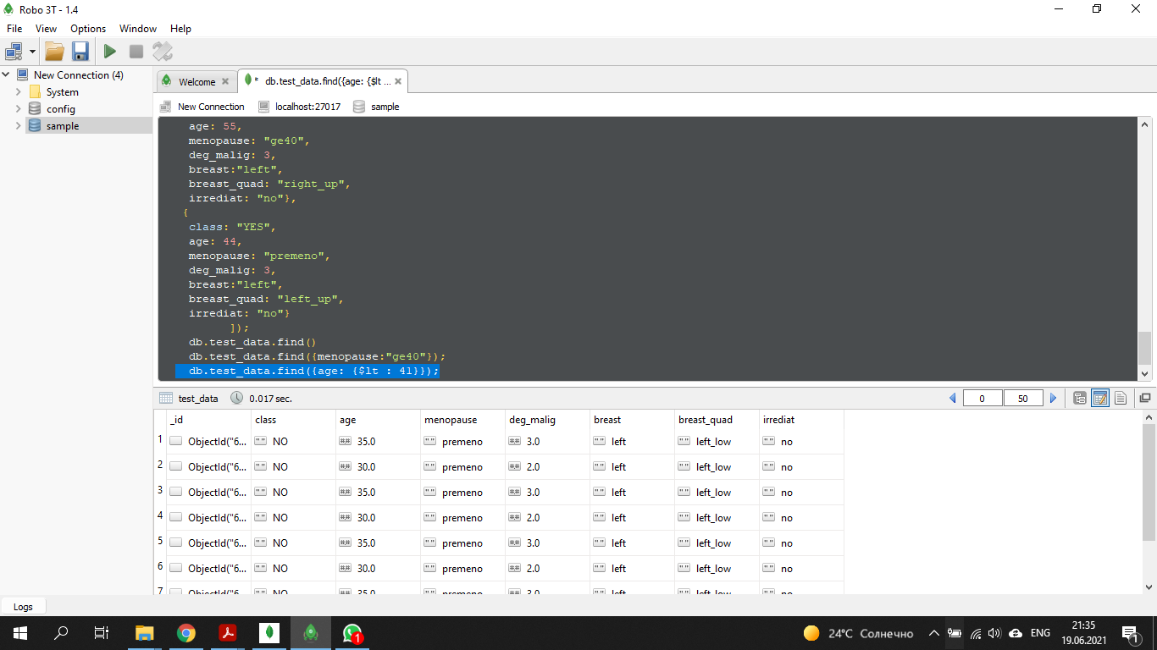

3c. Select all rows where age is less than 41 or the menopause column has the value “ge40”.
db.test_data.find( { $or:[ {age:{$lt : 41} }, {menopause: "ge40"}]});
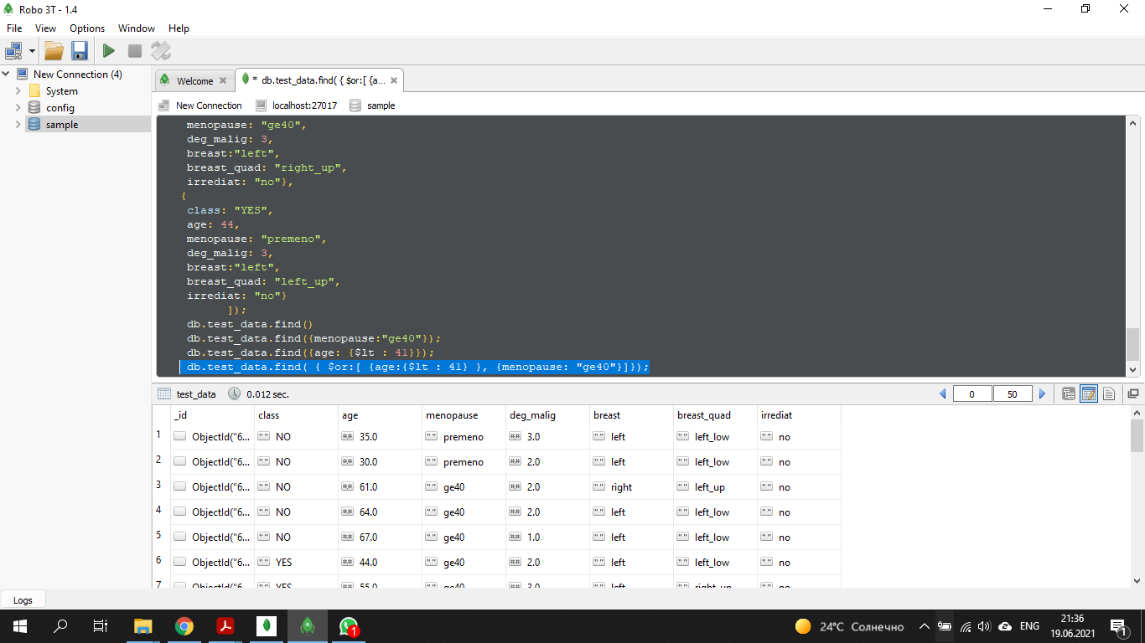
3d. Compute the average age across all rows.
db.test_data.aggregate([ { $group: { _id: null , avg_age: {$avg: "$age" } }}]);
